status information
Security classification: | Confidential  Restricted  Internal  Unclassified |  | Status: |  | Final
Current version number: | V1.0 | Date of first issue:
Prepared by: | CGI |  |  | Date:
Verified by: | Architects and experts DSIG |  |  | Date:
Approved by: | Grinsztajn Julien |  |  | Date:
Copyright notice
This document may not be reproduced (even partially) or communicated to third parties without the written authorization of the company’s General Management.
DISTRIBUTION LIST
Name | Address | I/A | Name | Address | I/A
Departments Architecture, Production and Telecom & Security CSPI and operators - Reviewers CVT |  | A
(I = for information, A = for action)
DOCUMENT CHANGE RECORD
Version | Date | Description | Affected sections
1.0 | 18/04/2016 | ASD initialization | Original version
2.0 | 04/05/2016 | Relecture transverse
Table of Contents

1 Application Solution Architecture Overview 4
1.1 Application Solution Design Goals 4
1.2 Application Solution Design Constraints 4
1.2.1 Business Constraints 4
1.2.2 Service Constraints 4
1.2.3 technical constraints: 6
1.3 Compliance to Policies & Standards 7
1.4 Future Contingencies 7
2 Requirements Summary 8
2.1 Functional/Information Requirements 8
2.2 Operational Requirements 8
2.3 Security Requirements 8
3 Application Solution Design 9
3.1 Functional Architecture 9
3.1.1 As Is Functional Architecture 9
3.1.2 To Be Functional Architecture 9
3.1.3 Functional Flows 9
3.1.4 on other Functions 12
3.1.5 Future Evolutions 12
3.2 Information Architecture 12
3.2.1 Conceptual Data Model 12
3.2.2 Logical Data Model 12
3.2.3 Data Formatting & Processing 12
3.2.4 Future Evolutions 12
3.3 Application Architecture 13
3.3.1 Application Architecture 13
3.4 Environments 14
3.4.1 Description of the plateforms 14
3.4.2 Sizing 15
3.4.3 Clearances 16
3.4.4 Deployment Architecture 16
3.5 Security Controls Design 18
3.5.1 run management 18
Reporting 18
Purge 18
Annex 19
3.6 References 19
3.7 Glossary 19
3.8 Appendices 21

Application Solution Architecture Overview

Application Solution Design Goals

GAIA is an infrastructure services and organization that manage identities and control access to the GDF SUEZ information system of collaborators, employees or group’s contractors, as well as some external people (service providers, partners or interims).

Application Solution Design Constraints

Business Constraints

Service Constraints

- Data exchanges take place on a scheduled basis.
- GENERAL SERVICE PERIODS:
Environment | Opening users | sensitive time system | Application sensitive period | call period system | application call period | Criticality Level | Type operating
Production | Standard 2 | 00h00 – 03h00 (for the weekly flows)  09h00 – 12h00 (for the monthly flows) | 00h00 – 03h00 (for the weekly flows)  09h00 – 12h00 (for the monthly flows) | Normal  (5 worked days from 08h00 – 18h00) | Normal  (5 worked days from 08h00 – 18h00) | C2 | OS MANAGE +  (except Oracle database : FULL MANAGE)
Pre production | Standard 2 | 00h00 – 03h00 (for the weekly flows)  09h00 – 12h00 (for the monthly flows) | 00h00 – 03h00 (for the weekly flows)  09h00 – 12h00 (for the monthly flows) | Normal  (5 worked days from 08h00 – 18h00) | Normal  (5 worked days from 08h00 – 18h00) | C2 | OS MANAGE +  (except Oracle database : FULL MANAGE)
Integration/ Development | Standard 2 | N/A | N/A | Normal  (5 worked days from 08h00 – 18h00) | Normal  (5 worked days from 08h00 – 18h00) | N/A | OS MANAGE +  (except Oracle database : FULL MANAGE)

- LEVEL AND QUALITY OF SERVICE INFORMATION:
Environment | Availability | Information integrity | Protection and confidentiality of information | traceability | rescue | PDMA | DIMA
Production | level 1 | I1 | P1 | T1 | S2 | 24H | 24H
Preproduction | level 1 | I1 | P1 | T1 | S2 | 24H | 24H
Integration  /Development | level 1 | I1 | P1 | T1 | S1 | N/A | N/A

- Availability:
The availability expected from the application is the standard level.

- Information integrity:
The INES platform is only used to transport data without modifying them. The information integrity is guaranteed by the respective data sources: PEGASUS applications and Clone EDF.

- Protection and confidentiality of information:
In the case of PEGASUS, the files are encrypted using the OPENSSL and AES-256 -CBC algorithm.

- traceability:
The traceability of exchanges is performed via the IHM INES-OSS included in the INES base.

- relief supplies:
In case of unavailability of the PROD environment, the PREPROD environment will be used according to DIMA deadlines.

technical constraints:
- CFT flow between SI HR and INES platform for the provision of the data stream.
- FTP between the INES platform and the GAIA platform
- SFTP between the INES platform and Horizon Directory
- SFTP between the INES platform and B2B Frontal INES
- SFTP between SIC @ D Application and B2B Frontal INES
- SFTP between PEGASUS application and B2B Frontal INES
- CFT between application SABINE EDF and the GAIA server
- SFTP between application SPRINT EDF and the GAIA server
- SFTP between application GAIA server and the Cristal Echanges
- SFTP Frontal B2B INES between application SPRINT CLONE EDF and the GAIA server
- FTP between the GAIA server and Site DCP
The project will use dedicated application components NR INES in the infrastructure INES broken down as follows:

ENVIRONMENT | INGREDIENTS
DEVELOPMENT | - The webMethods Integration Server v9.9  - The webMethods Broker Server v9.9  - Database of monitoring  - Database of traces  - Data Base Business  - Data replication Base  - Supervision OSS  - Cross Vista
INTEGRATION | - The webMethods Integration Server v9.9  - The webMethods Broker Server v9.9  - Database of monitoring  - Database of traces  - Data Base Business  - Data replication Base  - Supervision OSS  - Cross Vista
PRE-PRODUCTION | - The webMethods Integration Server v9.9  - The webMethods Broker Server v9.9  - Database of monitoring  - Database of traces  - Data Base Business  - Data replication Base  - Supervision OSS  - Cross Vista
PRODUCTION | - The webMethods Integration Server v9.9  - The webMethods Broker Server v9.9  - Database of monitoring  - Database of traces  - Data Base Business  - Data replication Base  - Supervision OSS  - Cross Vista

Compliance to Policies & Standards

The implementation of the solution is based on the application of several rules and standards.
RULE OR STANDARD | REFERENCE DOCUMENT
development of standards and packaging INES | DSIG-INES-MAN-NormeDeveloppementEtPackaging-05-032-v4.4

Future Contingencies
Not applicable.

Requirements Summary

Functional/Information Requirements

Functional / Information Requirement | Description
Expose services for sending files | Transmission and recovery of files.

Operational Requirements

Operational Requirement | Description

Security Requirements
Needs related to security constraints are described in the document ISP.

Security Requirement | Description
Securing exchanges | All exchanges must be secured  (Secure protocol FTPS / SFTP), including flows through the B2B brick

Application Solution Design
This section should refine and deepen the information previously indicated in the Business Case when necessary.

Functional Architecture
This section should details the Application Solution Design based on the Functional Architecture that serves as a framework.

As Is Functional Architecture
Sans Objet.

To Be Functional Architecture

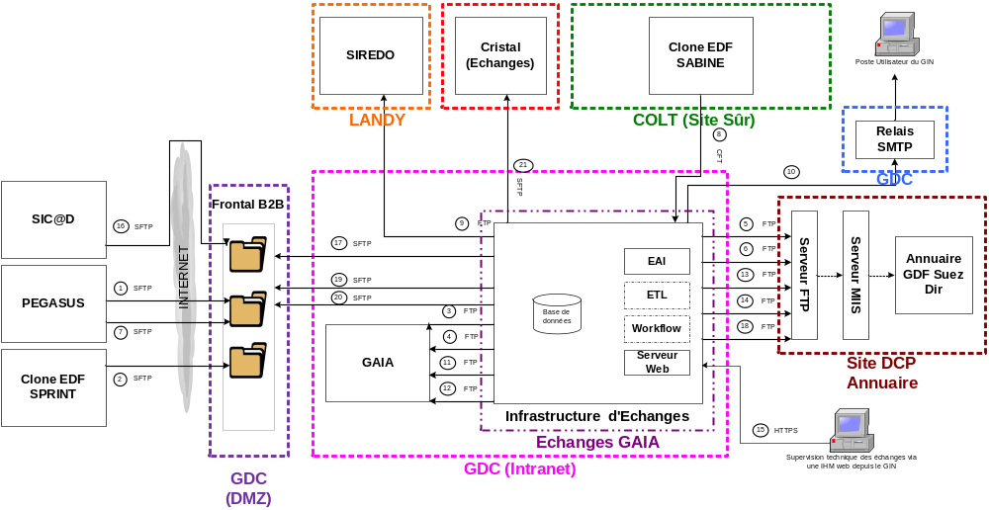

Functional Flows
A description of functional flows should be completed in the following table:
Functional Flow | From Functional Act | To Functional Act | Description
A1, A7 | Pegasus | Serveur Frontal B2B | - File deposit
A17,A19,A20 | Serveur Frontal B2B | INES-EXCHANGES | - File recovery
A2 | Clone EDF SPRINT | Serveur Frontal B2B | - File deposit
A8 | SABINE CLONE EDF | INES-EXCHANGES | - Sending file
A16 | SICAD | Frontal B2B INES | - File deposit
A3,A11,A4,A12 | INES-EXCHANGES | Serveur FTP GAIA | -sending files
A9 | INES-EXCHANGES | SIREDO | - sending files
A21 | INES-EXCHANGES | CRISTAL | - sending files
A10 | INES-EXCHANGES | Relais SMTP | - sending mail
A5,A6,A13,A14,A18 | INES-EXCHANGES | FTP MIIS | - sending files

Cinematic of exchanges:
- “Person” file:

cinematic | Technical Reference Flow
- The generation of the file by PEGASUS then sending it to the INES-EXCHANGES through B2B. | A1, A19
- Transmission of the file to GAIA after its treatment. | A3
- Transmission of the file to MIIS | A5

cinematic | Technical Reference Flow
- The generation of the file by CLONE EDF SPRINT then sending it to the INES-EXCHANGES through B2B. | A2, A19
- Transmission of the file to GAIA after its treatment. | A4
- Transmission of the file to MIIS | A6

- Reference file:

cinematic | Technical Reference Flow
- The generation of the file “reference tables” by PEGASUS then sending it to the INES-EXCHANGES through B2B | A7, A20
- Transmission of the file to GAIA | A11
- Transmission of the file to MIIS | A13
- Transmission of the files to SIREDO except the file “Buisness family” | A9
- Transmission of the file to CRISTAL | A21

cinematic | Technical Reference Flow
- The generation of the file “reference tables” by CLONE EDF SABINE then sending it to the INES-EXCHANGES through B2B | A8
- Transmission of the file to GAIA | A12
- Transmission of the file to MIIS | A14
- Transmission of the files to SIREDO except the file “Buisness family” | A9

- Update file

cinematic | Technical Reference Flow
- The generation of the file “Annuaire” by SICAD then sending it to the INES-EXCHANGES through B2B | A16, A17
- Transmission du fichier à GAIA. | A12
- Transmission of the file to MIIS | A18

Mapping of flux:
Production flow matrix: | Flow Matrix Pre Production:
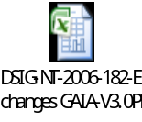
Flow Matrix Integ-rec: | Cartographie :
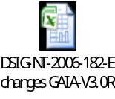 | 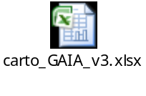

on other Functions
Not applicable.

Future Evolutions

Information Architecture

Conceptual Data Model
Cf. detailed functional specifications of GAIA Project.

Logical Data Model
Cf. detailed functional specifications of GAIA Project.

Data Formatting & Processing

Formatting
Cf. detailed functional specifications of GAIA Project.

Processing
Cf. detailed functional specifications of GAIA Project.

Future Evolutions
Not applicable.

Application Architecture

Application Architecture

As Is Application Architecture
The partner applications of GAIA are described in the following table:
Application | Description
SIREDO | Application of electronic document management.
PEGASUS | HR SI application of GDF Suez, managing payment and training for elements from the entities : GDFSUEZ , GRT GAZ ( RTG) , Storengy (STK ) , Elengy ( TME ) , Cycofos , DK6P , EM .
CLONE EDF | Clone applications SABINE and SPRINT of EDF SI managing payment and training for elements from the entities: GrDF, ErDF/common services, SEI/Corse (UM 0257), mixed central functions (7800M, 6202M, 6205M, 6207M, 6211M, 6218M, 6221M, 6600M, 8182M, 8390M).
FTP Server of Directory Interface | Interface server to feed the GDF SUEZ Directory. It provides data for MIIS server (Microsoft Identity Integration Server), which is responsible of merging this data for the directory.
SICAD | External application that feed the HR SI
Cristal | Application of tickets managment

To Be Application Architecture

Using crossVista as deployment tool:
Following the rise of webMethods version using the Deployment Tool CrossVista be generalized. The current deployment process-based tool "Deployer" will be impacted.

Using secure protocols
Using the FTP protocol will be replaced by the use of secure protocols FTPS/SFTP.

Application Flows / Interface
This table describes the application flows and interface with other applications:
From Application | To Application | Description | Frequency
Pegasus | Serveur Frontal B2B | - File deposit | Every 15 minutes
Serveur Frontal B2B | INES-EXCHANGES | - File recovery | Every 15 minutes
Clone EDF SPRINT | Serveur B2B SFTP | - File deposit | Every 15 minute
Serveur B2B SFTP | INES-EXCHANGES | - File recovery | Every 15 minute
SABINE CLONE EDF | INES-EXCHANGES | - Sending file
SICAD | Frontal B2B INES | - File deposit | The 27th of every month, at 23h (at the minutes: 5 & 35)
Frontal B2B INES | INES-EXCHANGES | - File recovery | The 27th of every month, at 23h (at the minutes: 5 & 35)
INES-EXCHANGES | Serveur FTP GAIA | -sending files
INES-EXCHANGES | SIREDO | - sending files
INES-EXCHANGES | CRISTAL | - sending files
INES-EXCHANGES | Relais SMTP | - sending mail
INES-EXCHANGES | FTP MIIS | - sending files

Impacts on other applications
Not applicable.

Future Evolutions
Not applicable.

Environments

Description of the plateforms
The environments available in the project are:
Name | Short Name | Description
Development | DEV | Environmental development and unit testing. It is dedicated to MOE teams.
Recipe | REC | Recipe environment MOA (TISI, business teams)
Pre-Production | PPRD | Pre-production environment; the only one with a similar infrastructure to that of production.  It can:  • Make the production start rehearsals in the closest possible conditions  • perform load testing and performance
Production | PRD | Environment of production.

Sizing

Environment | Synchronous | Asynchronous
Development | 1 (IS Business) | 1 IS Business
Recipe | 1 (IS Business) | 1 IS Business
Pre-Production | 1 (IS Business) | 1 IS Business  BDD mutualized
Production | 1(IS Business) | 1 IS  BDD mutualized

Clearances
Tools/ENV | DEV/FOR/REC | PPROD | PROD
webMethods Administration Console | Accessible to development teams with either:  - The username / pwd default administrator  - Specific IDs created for each user | Accessible only to the EIMS operator | Accessible only to the EIMS operator
My WebMetods Console Server | Access to achievement and revenue teams with username / pwd | Accessible to the operator, the application and conduct the MCO team with username / pwd specific | Accessible to the operator, the application and conduct the MCO team with username / pwd specific
management console OSS | Accessible with username / pwd single for all users | Accessible with username / pwd single for all users | Accessible to all users who have the role GAIA necessary to access it (access via GAIA)
File System | Accessible teams to realization with a username / pwd dedicated to each application.  Note that teams MOE do not have access to the entire File system, some files and directories require root privileges to read / change (exemple / etc) | Accessible only to the EIMS operator | Accessible only to the REIMS operator

Deployment Architecture

Deployment Overview
The solution used for deployment is CrossVista.
The CrossVista Team Server is a solution supplied by one of Software AG's partner publishers.
CrossVista makes it possible to produce a release / deliverable (export) and also offers the possibility of deployment in a different environment.
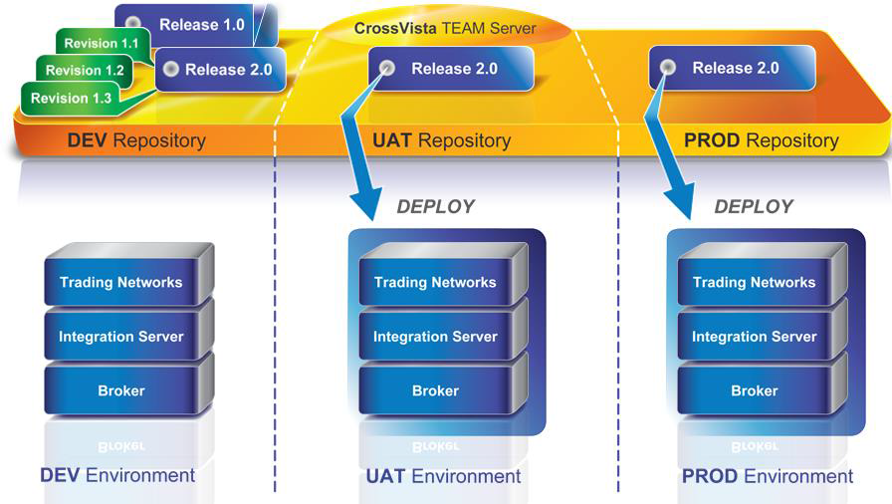

Description of deployment nodes
Properties | Values
Java home directory | /softs/java/jdk-7.1.0.15
Java min memory | 1024M
Java max memory | 1024M
Version | 9.6

Cf. CrossVista User Manual

Security Controls Design

run management

run management  type | Description
Supervision OSS | Supervision of trade is provided by the tool INES OSS base. This tool:  • Check the flow (date of treatment, duration of treatment, treatment status, the error message on failure)  • Find a stream by filtering on a list of criteria (called functional keys)  • Replay asynchronous flow in check
Reporting | after data replication in the replication database, a report describing the functional errors exchanges is sent daily to the profession
Logs /traces | The level of logging enabled on IS Metier is the default level: INFO (level 4).  Possible log levels are:  1. Fatal  2. Error  3. Warn  4. Info  5. Debug  6. Trace  The logs are available via:  • webMethods Administration Console at the section Logs / Server  • the file 'server.log' which is in the ... / IntegrationServer / logs /
archiving | The archiving policy is specific to each stream. For the archiving policy of a particular stream, refer to the document detailed functional specifications of the exchange in question.
replay | The replay policy is specific to each stream. To access the replay policy of a particular stream, refer to the document detailed functional specifications of the exchange in question.
Purge | The purge policy is specific to each stream. For a purge policy for a particular stream, refer to the document detailed functional specifications of the exchange in question.

Annex

References
Sans Objet.

Glossary
DSIG | Information Group Systems
+ DASL | Delegation of Architecture and Solutions
+ DI | IT delegation
| + Pôle Architecture | Architecture pole
| + Pôle Commercialisateur | Promoter pole
| + Pôle Telecom | Telecom pole
| + Pôle Rapsodie | Rapsodie pole
DGI | Direction of Major Infrastructures
+ CSI | Computing service center
| + DIC | Engineering and driving Department
| + DIC+ECA | Team of applications driving
| + DIC+EII | Engineering and Infrastructure Team
| + Pôle Tertiaire | Tertiary pole
| + …
DR | Research direction
+ DETI | Department of Economics and Information Processing
| + SII | IT Infrastructure Service
| + SIG | Internet Groupware
| + SIM | Computer Business Service
DS | Strategy Direction
Dircom | Communication Direction
DAR | Direction of Audit and Risk
DEP | Direction of Exploration and Production
GRT | Subsidiary Gas of France Transport Network
GRD | Direction Gas of France Distribution Network
EGD | Direction EDF Gaz of France Distribution
DRE | Delegation to the regulation and the economy
MPS | Permanent Security Mission
Dirco | Commercial Direction
DM | Delegation of Marketing
DCG | Direction Control of Management
DFC | Direction of Financing and Accounting
DIA | Direction of Investments and Acquisitions
DJ | Juridical Direction
DPRS | Staff and Social Affairs Direction
3D | Sustainable Development Department
DOMC | Delegation and Organization of Costs Control
DAG | Direction of groups sales
DRC | Delegation of group resources
DIM | Delegation of Real Estate
DIT | Direction of computing Network
EXS | Exploitation of servers
EXM | Exploitation of means
EXC | Exploitation of centers
MEP | Department into production
AEI | Agency of IT Operations (EDF)
BRIQUE | Coherent functional set of data or of applicative functions
CNIL | National commission of computing and freedom
CSA | Corresponding Servers and Applications (EXS)
DEX | Operating folder
DIMA | Maximum Unavailability Time allowable
DMZ | demilitarized zone
GFA | Closed Subscriber Group
GIN | Gas of France Interconnection
IHM | Human Machine Interface
LDAP | Lightweight Directory Access Protocol
MCO | Maintenance in working condition
MOA | Business Analyst
MOE | Mastery of work
PCS | Service Continuity Plan
PDMA | Maximum Allowable Loss of Data
PKI | Public Key Infrastructure
POA | Operational Application Driver
POP | Operational Project Driver
PQE | Operation Quality Plan
PSI | IT backup plan
PTE | Technical Operating Procedure
PTI | Technical Installation Procedure
PTM | Technical Migration procedure
PTR | Technical recovery procedure
RIN | National Internal Network
SGBD | Database Management System

Appendices
not applicable

